* Create a data base table: for Travel data

@EndUserText.label : 'Database table for travel data XXX'

@AbapCatalog.enhancementCategory : #NOT_EXTENSIBLE

@AbapCatalog.tableCategory : #TRANSPARENT

@AbapCatalog.deliveryClass : #A

@AbapCatalog.dataMaintenance : #RESTRICTED

define table ztravel_xxx {

key client : abap.clnt not null;

key mykey : sysuuid_x16 not null;

travel_id : /dmo/travel_id;

agency_id : /dmo/agency_id;

customer_id : /dmo/customer_id;

begin_date : /dmo/begin_date;

end_date : /dmo/end_date;

@Semantics.amount.currencyCode : 'ztravel_xxx.currency_code'

booking_fee : /dmo/booking_fee;

@Semantics.amount.currencyCode : 'ztravel_xxx.currency_code'

total_price : /dmo/total_price;

currency_code : /dmo/currency_code;

description : /dmo/description;

overall_status : /dmo/overall_status;

created_by : syuname;

created_at : timestampl;

last_changed_by : syuname;

last_changed_at : timestampl;

}

* Create a new Abap Class:

CLASS zcl_generate_travel_data_xxx DEFINITION

PUBLIC

FINAL

CREATE PUBLIC .

PUBLIC SECTION.

INTERFACES if_oo_adt_classrun.

PROTECTED SECTION.

PRIVATE SECTION.

ENDCLASS.

CLASS zcl_generate_travel_data_xxx IMPLEMENTATION.

METHOD if_oo_adt_classrun~main.

DATA itab TYPE TABLE OF ztravel_xxx.

* fill internal travel table (itab)

itab = VALUE #(

( mykey = '02D5290E594C1EDA93815057FD946624' travel_id = '00000022' agency_id = '070001' customer_id = '000077' begin_date = '20190624' end_date = '20190628' booking_fee = '60.00' total_price = '750.00' currency_code = 'USD'

description = 'mv' overall_status = 'A' created_by = 'MUSTERMANN' created_at = '20190612133945.5960060' last_changed_by = 'MUSTERFRAU' last_changed_at = '20190702105400.3647680' )

( mykey = '02D5290E594C1EDA93815C50CD7AE62A' travel_id = '00000106' agency_id = '070005' customer_id = '000005' begin_date = '20190613' end_date = '20190716' booking_fee = '17.00' total_price = '650.00' currency_code = 'AFN'

description = 'Enter your comments here' overall_status = 'A' created_by = 'MUSTERMANN' created_at = '20190613111129.2391370' last_changed_by = 'MUSTERMANN' last_changed_at = '20190711140753.1472620' )

( mykey = '02D5290E594C1EDA93858EED2DA2EB0B' travel_id = '00000103' agency_id = '070010' customer_id = '000011' begin_date = '20190610' end_date = '20190714' booking_fee = '17.00' total_price = '800.00' currency_code = 'AFN'

description = 'Enter your comments here' overall_status = 'X' created_by = 'MUSTERFRAU' created_at = '20190613105654.4296640' last_changed_by = 'MUSTERFRAU' last_changed_at = '20190613111041.2251330' )

).

* delete existing entries in the database table

DELETE FROM ztravel_xxx.

* insert the new table entries

INSERT ztravel_xxx FROM TABLE @itab.

* output the result as a console message

out->write( |{ sy-dbcnt } travel entries inserted successfully!| ).

ENDMETHOD.

ENDCLASS.

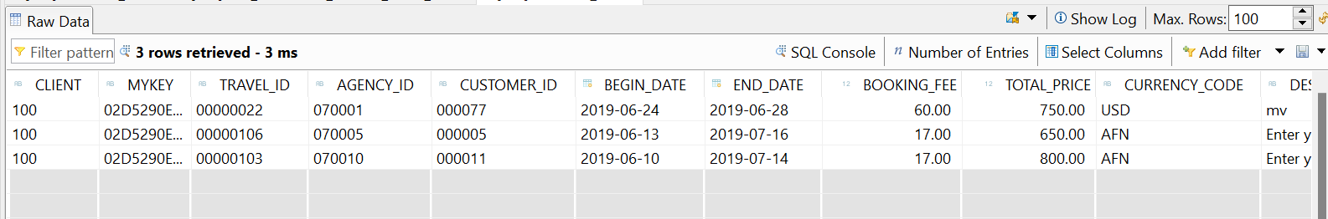

* Create a new Data definition for creating a data model for Travel App:

@EndUserText.label: 'Travel data XXX'

@AccessControl.authorizationCheck: #NOT_REQUIRED

**define** **root** **view** **entity** ZI_TRAVEL_M_746

**as** **select** **from** ztravel_746 **as** Travel

/* Associations */

**association** **[**0**..**1**]** **to** /DMO/I_Agency **as** _Agency **on** **$projection.**agency_id **=** _Agency**.**AgencyID

**association** **[**0**..**1**]** **to** /DMO/I_Customer **as** _Customer **on** **$projection.**customer_id **=** _Customer**.**CustomerID

**association** **[**0**..**1**]** **to** I_Currency **as** _Currency **on** **$projection.**currency_code **=** _Currency**.**Currency

**{**

**key** mykey**,**

travel_id**,**

agency_id**,**

customer_id**,**

begin_date**,**

end_date**,**

@Semantics.amount.currencyCode: 'currency_code'

booking_fee**,**

@Semantics.amount.currencyCode: 'currency_code'

total_price**,**

currency_code**,**

overall_status**,**

description**,**

/*-- Admin data --*/

@Semantics.user.createdBy: true

created_by**,**

@Semantics.systemDateTime.createdAt: true

created_at**,**

@Semantics.user.lastChangedBy: true

last_changed_by**,**

@Semantics.systemDateTime.lastChangedAt: true

last_changed_at**,**

/* Public associations */

_Agency**,**

_Customer**,**

_Currency

**}**

* Create Projection View for travel data:

@EndUserText.label: 'Travel projection view - Processor'

@AccessControl.authorizationCheck: #NOT_REQUIRED

@UI: {

headerInfo: { typeName: 'Travel', typeNamePlural: 'Travels', title: { type: #STANDARD, value: 'TravelID' } } }

@Search.searchable: true

**define** **root** **view** **entity** ZC_TRAVEL_M_746

**provider** **contract** **transactional_query**

**as** **projection** **on** ZI_TRAVEL_M_746

**{**

@UI.facet: [ { id: 'Travel',

purpose: #STANDARD,

type: #IDENTIFICATION_REFERENCE,

label: 'Travel',

position: 10 } ]

@UI.hidden: true

**key** mykey **as** TravelUUID**,**

@UI: {

lineItem: [ { position: 10, importance: #HIGH } ],

identification: [ { position: 10, label: 'Travel ID [1,...,99999999]' } ] }

@Search.defaultSearchElement: true

travel_id **as** TravelID**,**

@UI: {

lineItem: [ { position: 20, importance: #HIGH } ],

identification: [ { position: 20 } ],

selectionField: [ { position: 20 } ] }

@Consumption.valueHelpDefinition: [{ entity : {name: '/DMO/I_Agency', element: 'AgencyID' } }]

@ObjectModel.text.element: ['AgencyName'] ----meaning?

@Search.defaultSearchElement: true

agency_id **as** AgencyID**,**

_Agency**.**Name **as** AgencyName**,**

@UI: {

lineItem: [ { position: 30, importance: #HIGH } ],

identification: [ { position: 30 } ],

selectionField: [ { position: 30 } ] }

@Consumption.valueHelpDefinition: [{ entity : {name: '/DMO/I_Customer', element: 'CustomerID' } }]

@ObjectModel.text.element: ['CustomerName']

@Search.defaultSearchElement: true

customer_id **as** CustomerID**,**

@UI.hidden: true

_Customer**.**LastName **as** CustomerName**,**

@UI: {

lineItem: [ { position: 40, importance: #MEDIUM } ],

identification: [ { position: 40 } ] }

begin_date **as** BeginDate**,**

@UI: {

lineItem: [ { position: 41, importance: #MEDIUM } ],

identification: [ { position: 41 } ] }

end_date **as** EndDate**,**

@UI: {

lineItem: [ { position: 50, importance: #MEDIUM } ],

identification: [ { position: 50, label: 'Total Price' } ] }

@Semantics.amount.currencyCode: 'CurrencyCode'

total_price **as** TotalPrice**,**

@Consumption.valueHelpDefinition: [{entity: {name: 'I_Currency', element: 'Currency' }}]

currency_code **as** CurrencyCode**,**

@UI: {

lineItem: [ { position: 60, importance: #HIGH },

{ type: #FOR_ACTION, dataAction: 'acceptTravel', label: 'Accept Travel' } ],

identification: [ { position: 60, label: 'Status [O(Open)|A(Accepted)|X(Canceled)]' } ] }

overall_status **as** TravelStatus**,**

@UI.identification: [ { position: 70, label: 'Remarks' } ]

description **as** Description**,**

@UI.hidden: true

last_changed_at **as** LastChangedAt

**}**

* Create a Service Definition:

@EndUserText.label: 'Service Definition for ZC_Travel_M_XXX'

**define** **service** ZUI_C_TRAVEL_M_746 **{**

**expose** ZC_TRAVEL_M_746 **as** TravelProcessor**;**

**expose** /DMO/I_Customer **as** Passenger**;**

**expose** /DMO/I_Agency **as** TravelAgency**;**

**expose** /DMO/I_Airport **as** Airport**;**

**expose** I_Currency **as** Currency**;**

**expose** I_Country **as** Country**;**

**}**

* Create New Service Binding:

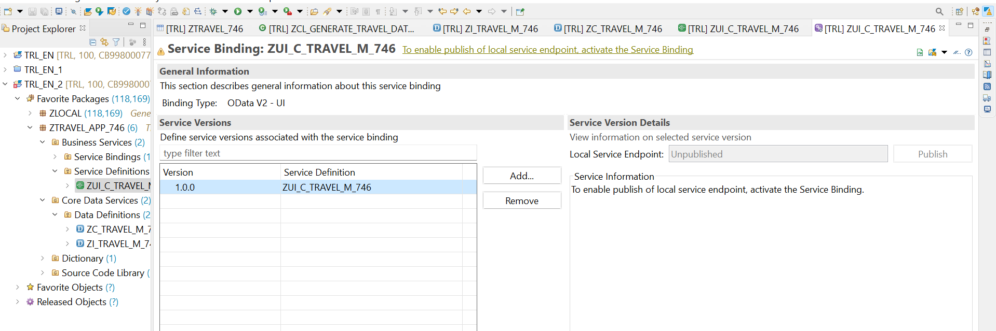

**Activate** your service binding and then **publish** it.

**And then click on the association and preview**

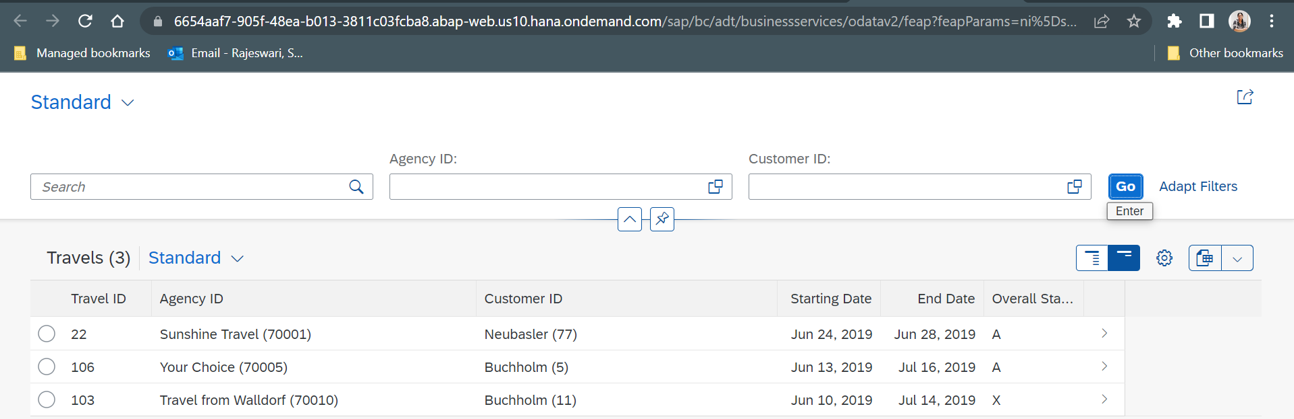

* Create behaviour definition:

managed implementation in class zbp_i_travel_m_746 unique;

define behavior for ZI_TRAVEL_M_746 alias Travel

persistent table ztravel_746

etag master last_changed_at

lock master

{

// semantic key is calculated in a determination

field ( readonly ) travel_id;

// administrative fields (read only)

field ( readonly ) last_changed_at, last_changed_by, created_at, created_by;

// mandatory fields that are required to create a travel

field ( mandatory ) agency_id, overall_status, booking_fee, currency_code;

// mandatory fields that are required to create a travel

field ( mandatory ) Begin_Date, End_Date, Customer_ID;

// standard operations for travel entity

create;

update;

delete;

}

* Create Behaviour Projection:

**projection;**

//strict ( 1 ); //Uncomment this line in order to enable strict mode 2. The strict mode has two variants (strict(1), strict(2)) and is prerequisite to be future proof regarding syntax and to be able to release your BO.

**define** **behavior** **for** ZC_TRAVEL_M_746_1 **alias** TravelProcessor

**{**

**use** **create;**

**use** **update;**

**use** **delete;**

**}**

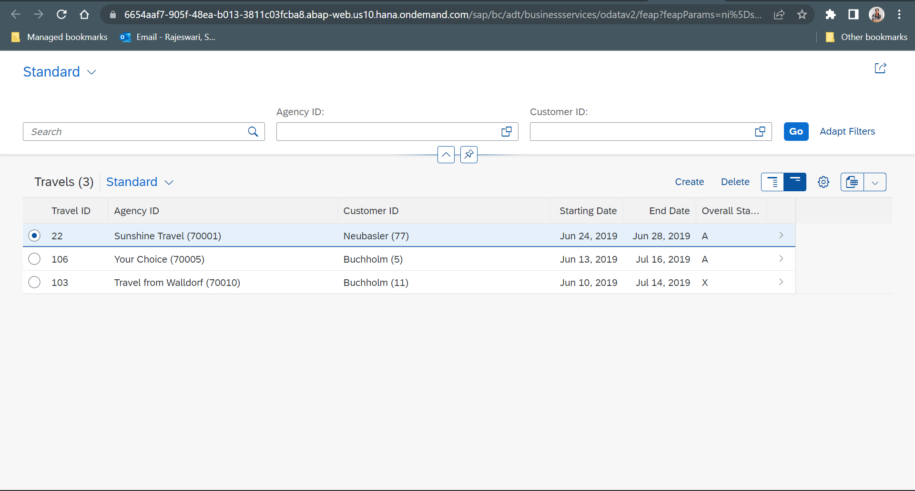

* Create a fiori app and deploy it into SAP BTP environment:
  + Create Dev space, Projects, CF:Login to Cloud foundry, Create fiori: open application generator:


 